Author FIRST*, Author SECOND¹ and Author LAST¹
All corrections please mark on red

ENGLISH TITLE
Abstract: Template of article for publication in the journal Ecological Chemistry and Engineering S/Chemia
i Inżynieria Ekologiczna S (ECES) along with a brief description of design. Examples of tables, figures, formulas, etc. were given.
Keywords: template, article format, ECES, Ecological Chemistry and Engineering S, Chemia i Inżynieria Ekologiczna S
Introduction
This template (MS Word) is designed to help authors of the article in formatting for publication in the journal Ecological Chemistry and Engineering S/Chemia i Inżynieria Ekologiczna S (ECES). The template shows article format, so it can be used as the basis for formatting your article. It is recommended to copy the format using Microsoft Word option
“Format painter” .
Page layout
Size of page: height 24.5 cm, width 17.5 cm. Margins: upper 2.7 cm,
lower 2.6 cm, right and left 2.25 cm. header 1.9 cm, footer 1.25. Therefore, writing space has dimensions of 19.2 cm (height) by 13 cm (width), and text, tables and figures should be adjusted to this size.
Authors and titles of article
Authors
Name/(s) and surname (in capital letters) of authors should be provided (font: 10 pts, paragraph spacing: before 54 pts, 24 pts after, justified). Affiliation (font: 8 pts; paragraph: justified) should be given in English according to template and mark the author for correspondence with asterisk (*) and enter the email.
Article titles
Titles at the beginning of the article:
- English title (font: 12 pts, bold; paragraph spacing: after 18 pts, centred).
- Polish title (font: 10 pts, bold, paragraph spacing: after 30 pts, centred).
Polish title at the end of the article: (font: 10 pts, bold, paragraph spacing: before
20 pts, after 10 pts, centred).
Polish title will be added by publisher.
Abstract and keywords
Article at the beginning should include an abstract and keywords in English. Abstract (font: 8 pts, bold only the word Abstract and a colon (Abstract:); paragraph spacing: after
6 pts, justified). Keywords (Font: 8 pts, bold only the word Keywords and colon (Keywords:); paragraph spacing: after 36 pts, hanging indentation 1.4 cm, justified).
Pagination
Pagination is divided on three parts:
- first page - DOI number of article and journal name
- even page - authors names (font: 8 pts, centred)
- odd page - English title (font: 8 pts, centred)
Titles within the article
Titles within the article are unnumbered, differ in font sizes. The paper use three orders of titles: the first, second and third. Title should always be on the same page as the text. It is not recommended to use the titles of the fourth and lower orders (instead you can use the list and bullets).
First order title
First order title ie References, Results etc. (font: 12 pts, bold; paragraph spacing: before 10 pts, after 6 pts, aligned to the left).
Second order title
Second order title, less important (font: 10 pts, bold; paragraph spacing: before 8 pts, after 5 pts, aligned to the left).
Third order title
Third order title, the least important (font: 10 pts, italic; paragraph spacing: before
8 pts, after 5 pts, aligned to the left).
Main text of article
Main text of article (font: 10 pts; paragraph: justified, line spacing: single, indentation: first line 0.65 cm). It is urged to follow the units recommended by the Systéme Internationale d'Unites (SI). Symbols recommended by the International Union of Pure and Applied Chemistry (Pure Appl Chem. 1979;51:1-41) are to be followed.
Equations
Equations should be prepared with Insert Equation tool in Microsoft Word. Equations should be written in italics (font (set in Insert Equation): normal 10 pts, subscript/superscript 6 pts, symbol 18 pts; paragraph spacing: before 3 pts, after 3 pts, centred). In the case of the numbering, pattern number (in parentheses) should be on the right side of the formula.
(1)
Figures
Drawing should be clear (suitable quality), lie on one page (in exceptional cases can be divided into two pages). Figures should be numbered consecutively. Graphic material (drawings, charts) should be provided in the form of digital vector file, for example with programs: CorelDraw version 9.0, Excel, or at least a bitmap (TIF, JPG). Axles charts should absolutely include a description and units (placed in square brackets []). Figure should be preceded by a blank line.
In the Figures, which are composed of at least two parts (a, b, ...), it should be explicitly described (see example).
Template
So Figure should look like template below:

a) |  | b) | 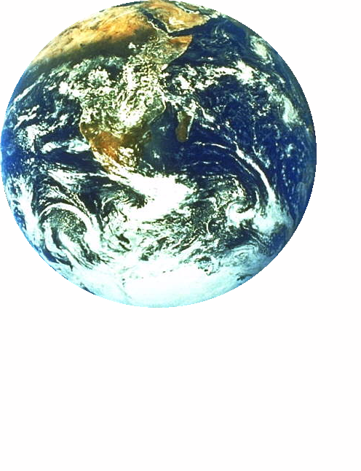
Fig. 1. Logos: a) Society of Ecological Chemistry and Engineering (Towarzystwo Chemii i Inżynierii Ekologicznej), b) ECOpole’12 Conference
Figure description: (font: 8 pts; paragraph spacing: before 3 pts, after 18 pts, justified, indentation left and right: 0.5 cm, hanging indentation: 0.9 cm) should be placed below the Figure on the same page.
Tables
Table (font: 8 pts, centred, maximal width of table 13 cm) should fit on one page
(in exceptional cases can be divided into two pages). Tables should be numbered consecutively. The heading row of table should be bolded. Before and after the table should be one blank line.
Template
So Table should look like template below:

Table 1
Types of article titles and their appearance
Type | Font | Paragraph spacing | Comments
 | [pts] | [pts]
I order | 12 | before 10, after 6 | bold, aligned to the left
II order | 10 | before 8, after 5 | bold, aligned to the left
III order | 10 | before 8, after 5 | italic, aligned to the left*
* indications in table (font: 8 pts, paragraph spacing: before 3 pts)

In the table should be given units recommended by the Systéme Internationale d'Unites (SI) (placed in square brackets []).
Lists
You can use numbered or bulleted list (paragraph: hanging indentation 0.65 cm) with:
1. numbers
a) letters
- dashes
• dots
References
The references should be cited chronologically in square brackets [] in the text. References at the end should be formatted as follows (font: 8 pts, paragraph: hanging indentation 0.65 cm, the number in parentheses separated from the rest with tabulator). In the references should be indicated DOI number (if available, most publishers give it on the article front page).
Templates
[l] Lowe DF, Oubre CL, Ward CH. Surfactants and cosolvents for NAPL remediation. A technology practices manual. Boca Raton: Lewis Publishers; 1999.
[2] Fasino CR, Carino M, Bombelli F. Oxidant profile of soy standardized extract. In: Rubin R, Stryger CS, editors. Joint Meeting 2001 - Book Abstracts ‘2001 Year of Natural Products Research’. New York: Harper and Row; 2001.
[3] Wosiński S. Effect of composition and processing conditions of ceramic and polymer composites on the electric field shielding ability [PhD Thesis]. Poznań: Poznan University of Technology; 2010.
[4] Trapido M, Kulik N, Veressinina Y, Munter R. Water Sci Technol. 2009;60:1795-1801.
DOI: 10.2166/wst.2009.585.
[5] Cañizares P, Lobato J, Paz R, Rodrigo MA, Sáez C. Chemosphere. 2007;67:832-838.
DOI: 10.1016/j.chemosphere.2006.10.064.
[6] Hakala M, Nygård K, Manninen S, Huitari S, Buslaps T, Nilsson A, et al. J Chem Phys.
2006:125:084504-1-7. DOI: 10.1063/1.2273627.
[7] Simeonov D, Spasov L, Simeonova P. Statistical calibration of model solution of analytes. Ecol Chem Eng S. Forthcoming 2022.

Affiliation in English, Street with number, City with postal code, Country, phone with country prefix, fax with country prefix, email: address@email.com * Corresponding author: address@email.com

